ELECTRONICS 2

AC Amplifier with an Op-Amp

Lab 4 Report

Johannah Rosenblum

Antony Sotirov

Evgeniy Nudga

# Task 1: AC Amplifier with an Op-Amp

#### Objective

#### Build-up an AC amplifier based on an op-amp.

#### 1)Measure the DC input and output quiescent points and the voltage gain.

#### 2)Measure the transfer characteristic AV[dB] = f(ω) for frequencies fin > 2,5kHz.

#### Set Up

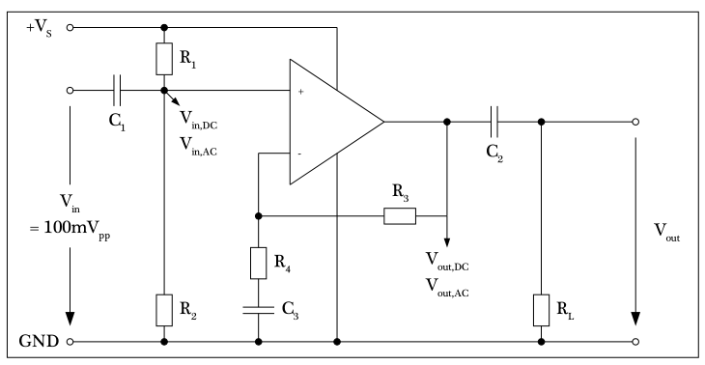

Figure 1: Non-Inverting Op-Amp

#### Supplies

1x Operational Amplifier 741

2x Multimeter (2x Voltmeter)

1x Oscilloscope

1x DC Voltage Source (Vdc = 15V)

1x Signal Generator (Vin = 100mVpp sinwave)

5x Resistor (R1 = 10kΩ, R2 =10kΩ, R4 = 22kΩ, R4 = 1 kΩ, RL = 1kΩ)

3x Capacitor (C1 = 10µF, C2 =10µF, C3 = 1µF)

#### DC-Biasing measurement

#### After setting up the circuit, the following results were observed:

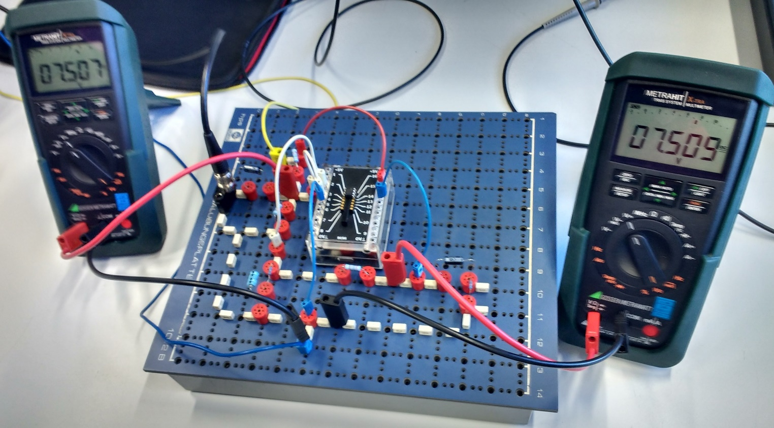

Figure 2: DC input and output quiescent points

Note: In this setup the AC input is connected on the border of the breadboard. This is problematic because connections on the border are shorted. In subsequent sections, the problem was resolved.

DC input and output quiescent points:

* VDC-in, QP = 7.507V
* VDC-out, QP = 7.509V

#### Voltage gain:

$A_{V}=\frac{OutputVoltage}{InputVoltage}=\frac{7.5V}{7.5V}=1$

To understand this result, compare it to the voltage gain calculated directly from the circuit. For a non-inverting op-amp,

$Av=1+\frac{{Impedance}_{feedback}}{{Impedance}_{ground}}$

$Av=1+\frac{R_{3}}{R_{4}+X_{C_{3}}}=1+\frac{R_{3}}{R_{4}+\frac{1}{jωC_{3}}}$

For DC signals, ω = 0, therefore take the limit of Av as ω → 0

$\lim_{ω→0}\left(1+\frac{R_{3}}{R_{4}+\frac{1}{jωC_{3}}}\right)=1$

* *AC-Transfer Characteristic at 2,5kHz*

Set-up the oscilloscope to match the following settings:

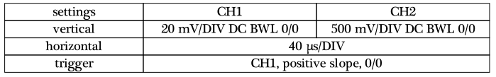

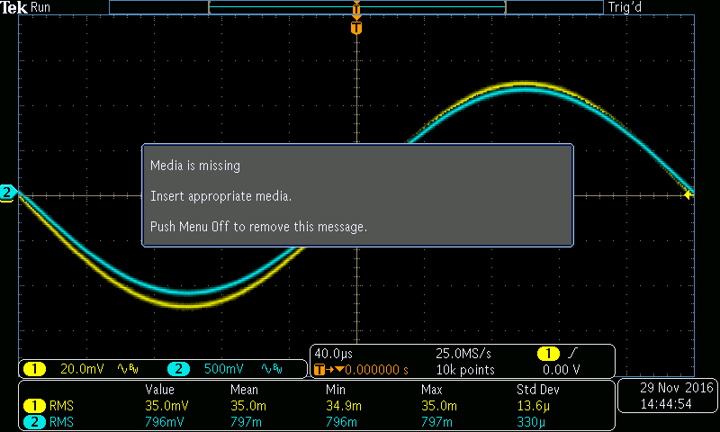

Figure 3: AC input (yellow line) and output (blue line) at 2,5kHz

Question: should we use another group’s screenshot?

|  |  |  |  |  |
| --- | --- | --- | --- | --- |
| **Frequency** | **Input (mV)** | **Output (mV)** | **Gain** | **Gain (dB)** |
| 2500 | 35 | 796 | 22.74285714 | 27.13690047 |

Note regarding oscilloscopes: The measurement are calculated from the displayed signal. To get the most precise measurements, display one full period and the vertical scaling should be as big as possible without cutting-off the peaks (i.e., the curve should be made to fit the display).[reword]

* *Gain as a function of frequency:* **AV*[dB] = f(*ω**)

|  |  |  |  |  |
| --- | --- | --- | --- | --- |
| **Frequency** | **Input (mV)** | **Output (mV)** | **Gain** | **Gain (dB)** |
| 2000000 | 34.6 | 12.3 | 0.355491329 | -8.983419747 |
| 1000000 | 35 | 25.1 | 0.717142857 | -2.887886457 |
| 500000 | 35 | 50.6 | 1.445714286 | 3.20164945 |
| 200000 | 35 | 126 | 3.6 | 11.12605002 |
| 100000 | 35 | 237 | 6.771428571 | 16.61360603 |
| 50000 | 35 | 433 | 12.37142857 | 21.84839704 |
| 20000 | 35 | 695 | 19.85714286 | 25.9583352 |
| 10000 | 35 | 776 | 22.17142857 | 26.91587354 |
| 5000 | 35 | 796 | 22.74285714 | 27.13690047 |
| 2000 | 35 | 795 | 22.71428571 | 27.12598169 |
| 1000 | 35 | 785 | 22.42857143 | 27.01603225 |
| 500 | 35 | 752 | 21.48571429 | 26.64299592 |
| 200 | 35 | 616 | 17.6 | 24.91025336 |
| 100 | 35 | 424 | 12.11428571 | 21.66595624 |
| 50 | 34.7 | 241 | 6.945244957 | 16.83375136 |
| 20 | 33 | 105 | 3.181818182 | 10.05350718 |
| 10 | 28.7 | 59 | 2.055749129 | 6.259402298 |

Note: only the frequency is in a logarithmic scale.

Conclusion: ….

#### Calculating the cut-off frequencies; fc,min, fc,max

#### The cut-off frequencies are at -3dB or at 70% of the maximum gain. Approximately based on the measured data:

$27dB–3dB=24dB$

$70∗23=16,1$

|  |  |  |  |  |
| --- | --- | --- | --- | --- |
| **Frequency** | **Input (mV)** | **Output (mV)** | **Gain** | **Gain (dB)** |
| 176 | 35 | 583 | 16.65714286 | 24.43201021 |
| 33900 | 34.7 | 560 | 16.13832853 | 24.15717104 |